CFD SIMULATION OF WATER FLOW THROUGH A 2D VENTURI METER USING COMSOL MULTIPHYSICS

Names | UGWOKE KENECHUKWU PERFECTUS
Reg. No | 2022/241806
Experiment No | 6
Group No. | 4

Objective of Experiment / Simulations

The primary objective of this simulation is to investigate the behavior of water flow through a Venturi meter using Computational Fluid Dynamics (CFD). Specifically, the goals are:
- To model the velocity, pressure, and turbulence distribution within a Venturi meter under steady-state, incompressible flow conditions.
- To validate the Venturi effect (increase in velocity and corresponding pressure drop at the throat).
- To analyze turbulence characteristics using the k-ε turbulence model.
- To compare numerical predictions with theoretical equations derived from Bernoulli’s principle and the continuity equation.
- To establish the accuracy of CFD simulations in predicting real-world flow measurement device performance.

Theory/Background

The Venturi Effect
A Venturi meter is a flow measurement device that operates on the Venturi effect, which states that when a fluid flows through a constricted section of pipe, its velocity increases while its static pressure decreases. The measurable pressure difference between the inlet and the throat can be used to determine the flow rate.
Governing Equations
1. Continuity Equation (Conservation of Mass):
A₁V₁ = A₂V₂ (1)
where:
- A = cross-sectional area (m²)
- V = velocity (m/s)
2. Bernoulli’s Equation (Conservation of Energy between inlet and throat):
P₁ + 1/2 ρV₁² = P₂ + 1/2 ρV₂² (2)
where:
- P = static pressure (Pa)
- ρ = density of water (~1000 kg/m³)
3. Flow Rate Equation:
Q = C_d A₂ √( (2(P₁ - P₂)) / (ρ (1 - (A₂/A₁)²)) ) (3)
where:
- Q = volumetric flow rate (m³/s)
- C_d = discharge coefficient (dimensionless)
4. Navier–Stokes Equations (Momentum Conservation in CFD):
ρ (∂u/∂t + u⋅∇u) = -∇p + μ∇²u + F (4)
where u = velocity vector, μ = viscosity, p = pressure, F = body forces.
5. Turbulence Model (k-ε):
The standard k-ε model solves for:
- Turbulent Kinetic Energy (k):
∂k/∂t + u_j ∂k/∂x_j = P_k - ε + ∂/∂x_j [ (ν + ν_t/σ_k) ∂k/∂x_j ] (5)
- Dissipation Rate (ε):
∂ε/∂t + u_j ∂ε/∂x_j = C_{1ε} ε/k P_k - C_{2ε} ε²/k + ∂/∂x_j [ (ν + ν_t/σ_ε) ∂ε/∂x_j ] (6)

Procedure (Step-by-step)

- Geometry Construction: I created a 2D geometry using the following dimensions.
  - Inlet diameter: D = 42 mm.
  - Throat diameter: D_t = 15 mm.
  - Throat length: L_t = 40 mm.
  - Inlet length: L_in = 180 mm.
  - Outlet length: L_out = 110 mm.
- Material Selection: In the material selection windows, I selected “Liquids and Gases”, selected “Liquid” and selected “Water”. The following properties were already preset.
  - Fluid: Water.
  - Density: ρ = 1000 kg/m³.
  - Dynamic viscosity: μ = 1.0 × 10⁻³ Pa·s.
- Physics Setup: I assumed non-slip conditions, incompressible fluid and turbulent flow and adjusted settings accordingly as specified below.
  - Flow type: Incompressible turbulent flow.
  - Turbulence model: Standard k-ε model.
  - Wall treatment: Wall functions.
  - Walls: No-slip boundary condition.
  - Gravity: Neglected.
- Boundary Conditions: I set the following boundary conditions.
  - Inlet: Velocity inlet, U = 0.011 m/s.
  - Outlet: Pressure outlet, P = 0 Pa (gauge).
  - Walls: No-slip condition.
- Meshing: I used the following settings which is the “Normal” preset in COMSOL to create the mesh. This is due to limitations in the available computing power.
  - Combination of triangular and quadrilateral elements.
  - Boundary layer mesh refinement near walls.
  - Minimum element size: 8.4 × 10⁻⁵ m.
  - Total elements: ~20,000.
- Solver Settings: I used the following default solver settings.
  - Study type: Steady-state.
  - Solver: Segregated with pseudo time stepping.
  - Residuals reduced to ~10⁻¹⁴.
- Post-Processing: I generated the following plots of the simulation.
  - Velocity surface, contours and streamlines.
  - Pressure surface and contours.

Result & Discussion
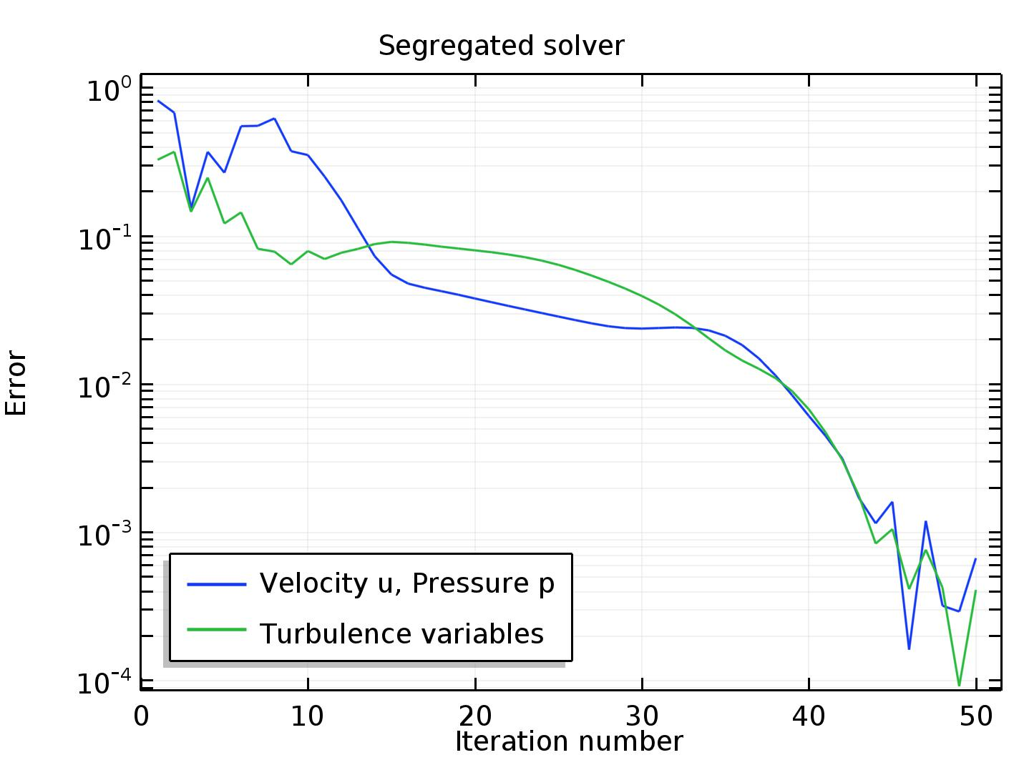
Convergence Plot

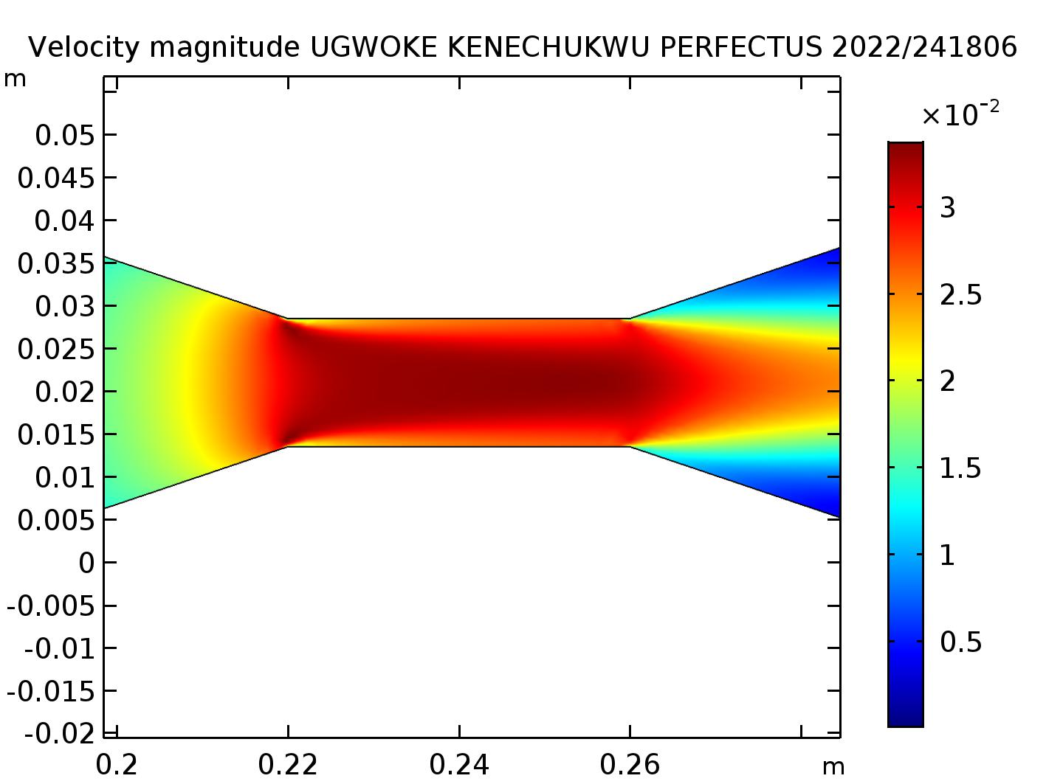
Velocity Surface
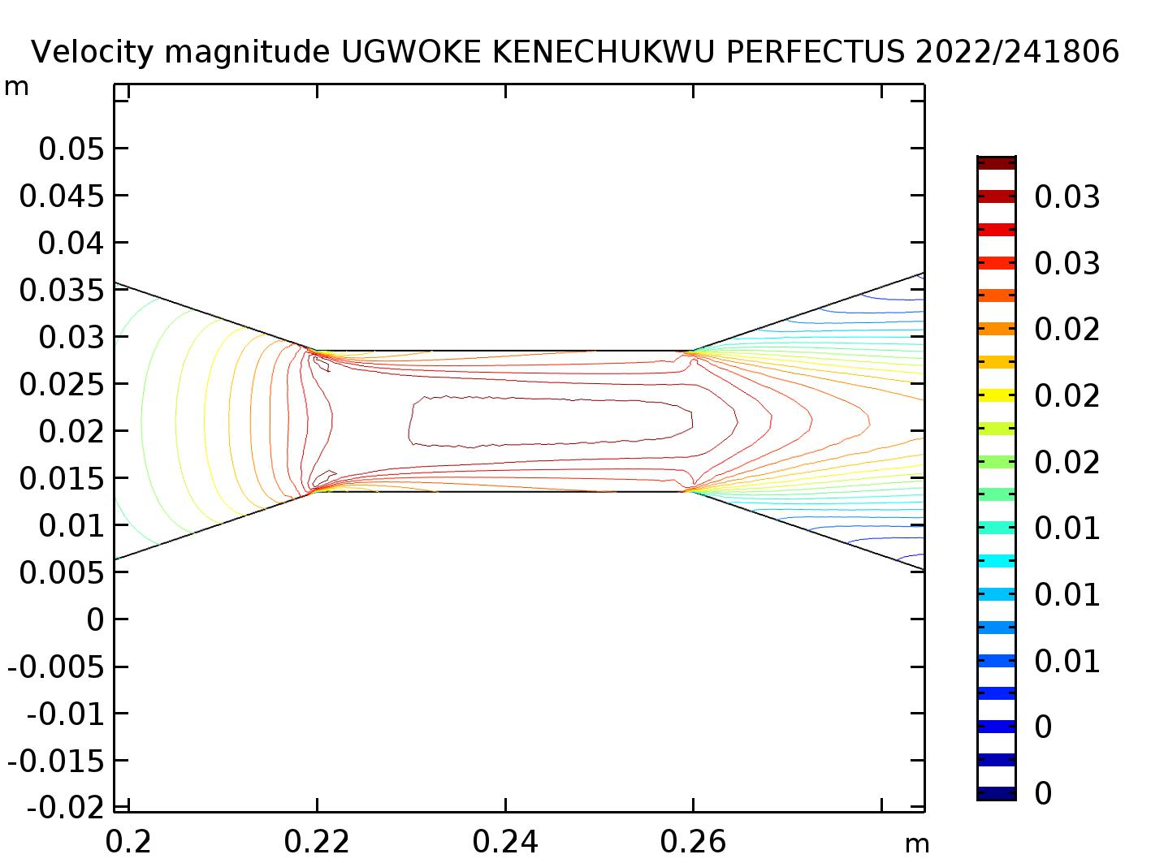

Velocity Contour

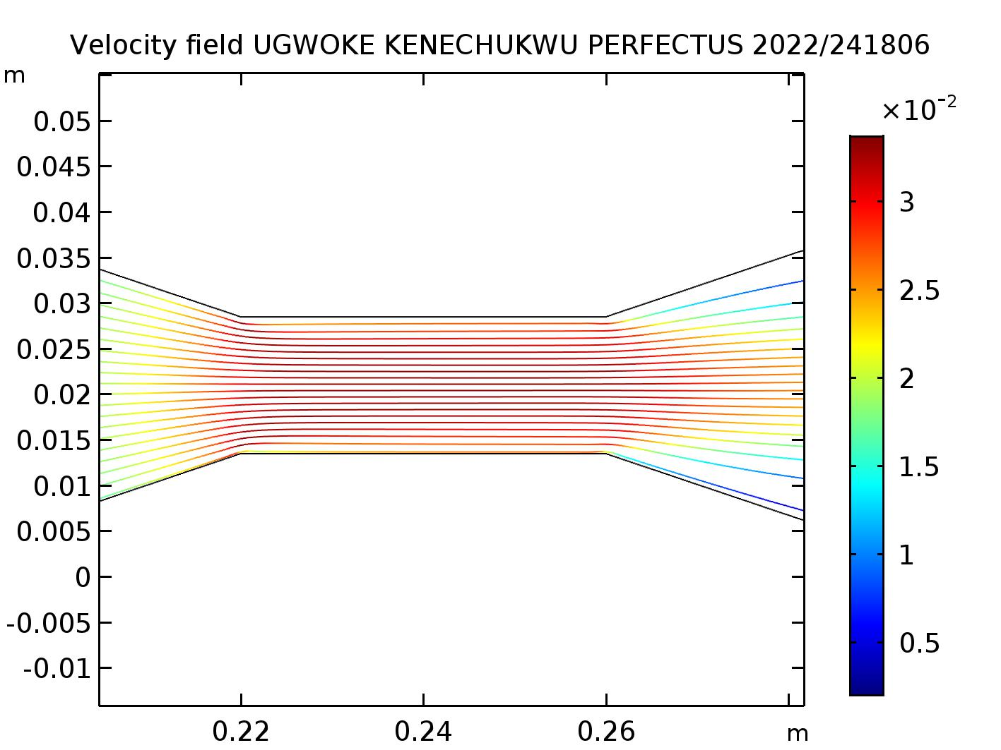
Velocity Streamline

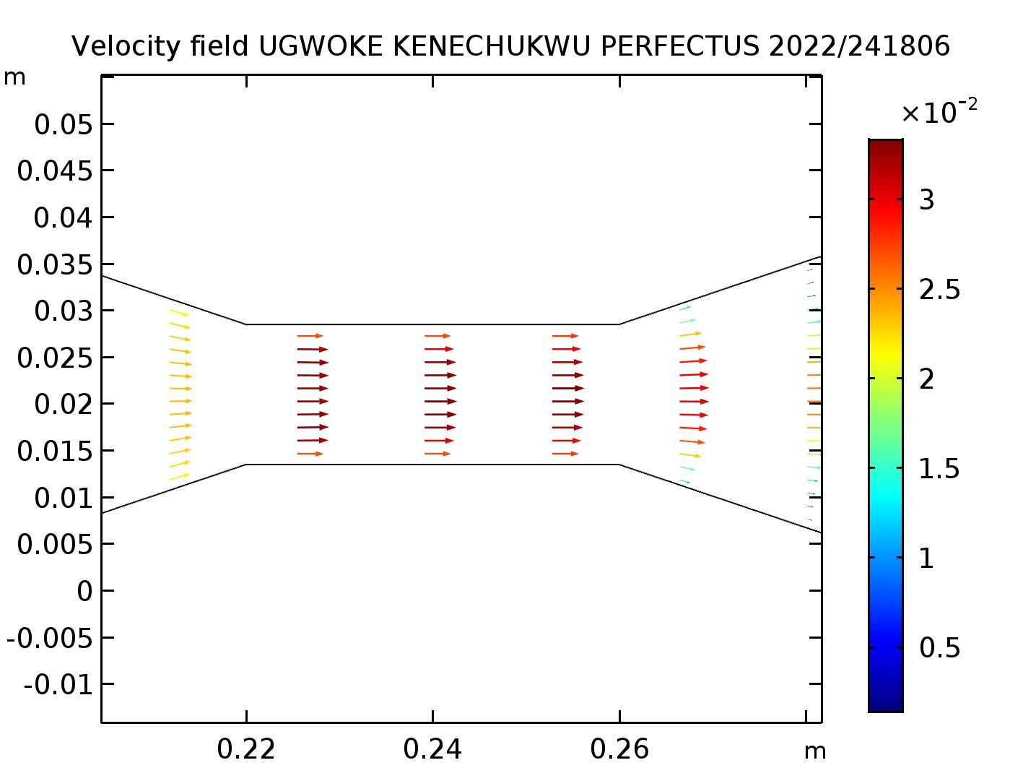
Velocity Arrow Surface

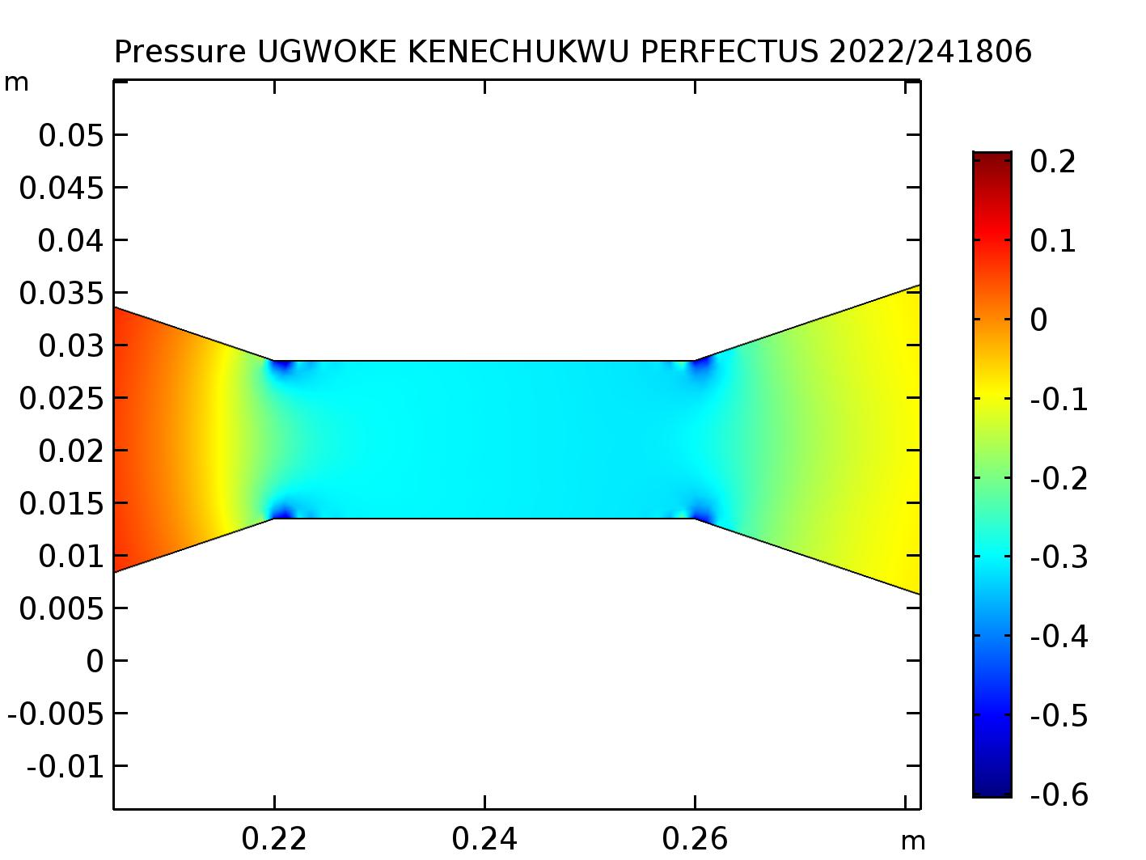
Pressure Surface

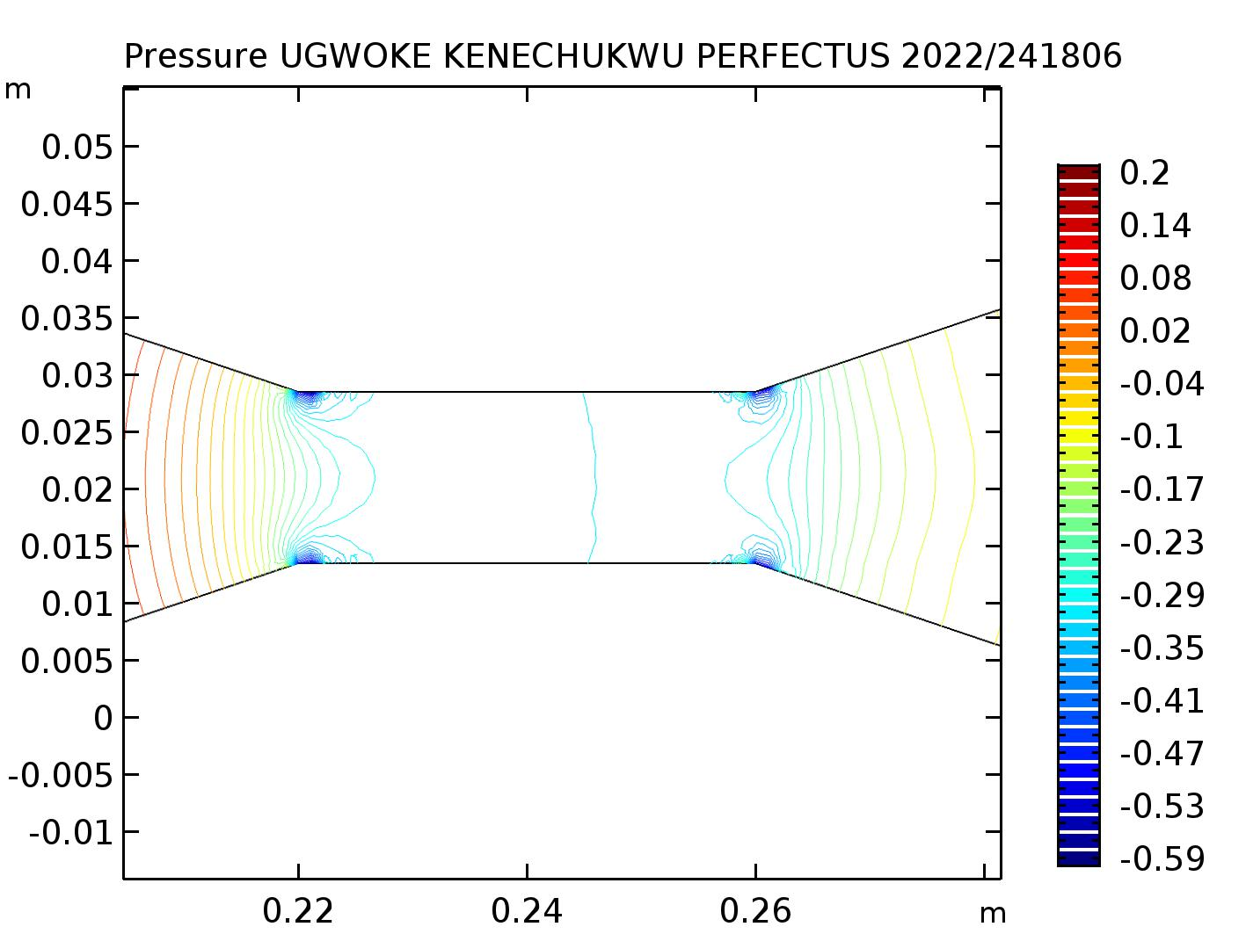
Pressure Contour

Pressure Distribution
- The simulation showed a significant pressure drop at the throat.
- Maximum pressure: At the inlet.
- Minimum pressure: At the throat.
- Pressure recovery: Occurs in the diffuser but is incomplete due to viscous effects and turbulence losses.
4.2 Velocity Distribution
- Inlet velocity: V₁ = 0.011 m/s.
- Throat velocity:
V₂ = (A₁/A₂) V₁ = ( (0.042²) / (0.015²) ) × 0.011 ≈ 0.086 m/s (7)
- CFD velocity predictions closely matched this theoretical value.
- Velocity vectors showed smooth acceleration in the convergent section and deceleration in the diffuser.
4.3 Turbulence Behavior
- Turbulent kinetic energy peaked near the throat and diffuser exit.
- High turbulence intensities corresponded to regions of strong velocity gradients.
- Wall shear stress was greatest near the throat due to flow constriction.
4.4 Validation with Theory
- Pressure drop and velocity increase confirmed Bernoulli’s principle.
- Continuity equation was satisfied, with inlet and throat flow rates matching.
- CFD predictions validated classical fluid mechanics theory.

Conclusion
- The CFD simulation successfully demonstrated the Venturi effect.
- Velocity increased and pressure decreased at the throat, matching theoretical expectations.
- The k-ε turbulence model provided a reasonable prediction of turbulence generation and dissipation.
- Results aligned with theoretical values, validating the CFD methodology.
Recommendations for Future Work:
- Perform simulations at higher inlet velocities to investigate compressibility effects.
- Test alternative turbulence models for improved accuracy.
- Carry out mesh independence studies to confirm solution accuracy.
- Compare with experimental data to calibrate the discharge coefficient C_d.

